Yuwen Sang

Week 4 Exercise

Screen Shot for question 3, 4, 5

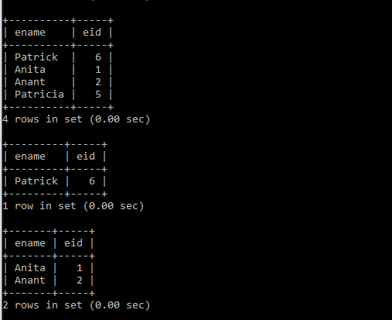

**Code for question 1-5**

#1. Find the name and id of employees who are working on project number 101

Select E.ename, E.eid

from WorksOn W, Employee E

where W.eid = E.eid and W.pid = 101;

#2 Find the name and id of emploees who are working on project number 103

Select E.ename, E.eid

from WorksOn W, Employee E

where W.eid = E.eid and W.pid = 103;

#3. Using the SQL Union operator, write a query to find the name/id of employees who

# are working on project 101 or 103

Select E.ename, E.eid

from WorksOn W, Employee E

where W.eid = E.eid and W.pid = 101

union

Select E.ename, E.eid

from WorksOn W, Employee E

where W.eid = E.eid and W.pid = 103;

#4. Write a nested query to find the name/id of employees who are working on both

# projects 101 and 103.

Select E1.ename, E1.eid

from WorksOn W1, Employee E1

where W1.eid = E1.eid and W1.pid = 101 and W1.eid in

(select E2.eid

from WorksOn W2, Employee E2

where W2.eid = E2.eid and W2.pid = 103);

#5. Write a nested query to find the name/id of employees who re working

# on 101 but not on 103.

Select E1.ename, E1.eid

from WorksOn W1, Employee E1

where W1.eid = E1.eid and W1.pid = 101 and W1.eid not in

(select E2.eid

from WorksOn W2, Employee E2

where W2.eid = E2.eid and W2.pid = 103);